Computer Networks Laboratory Week 4

Name : Tanishq Vyas
SRN : PES1201800125
Section : H
Semester : 5
Branch : CSE

First Test : Ping www.flipkart.com

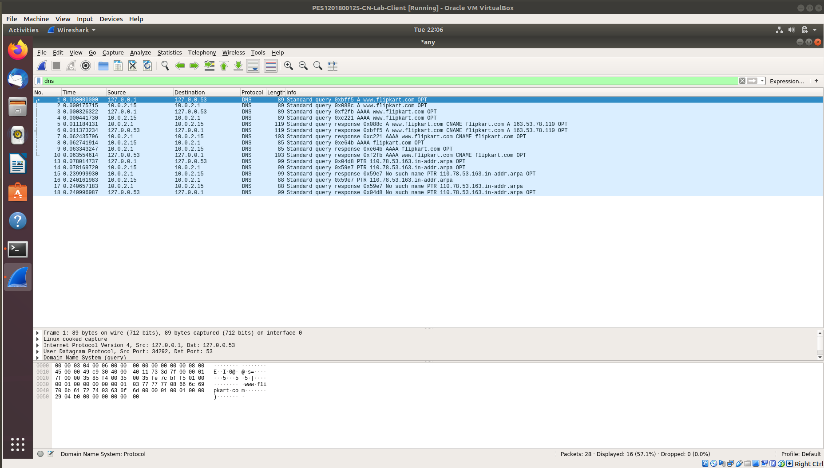

Screen Capture for DNS (query)
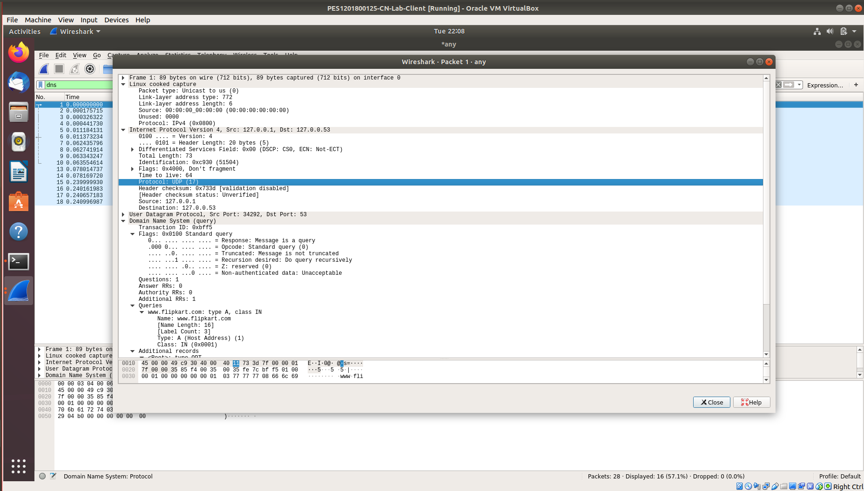

Screen Capture for DNS (response)

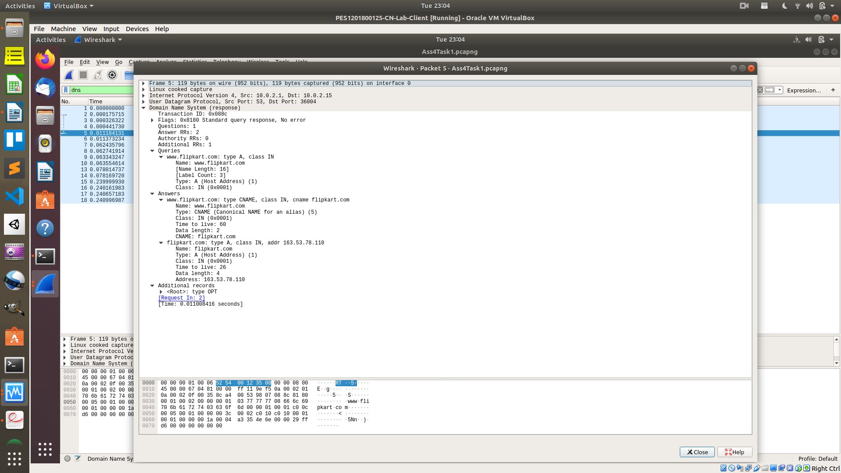

Dig Command

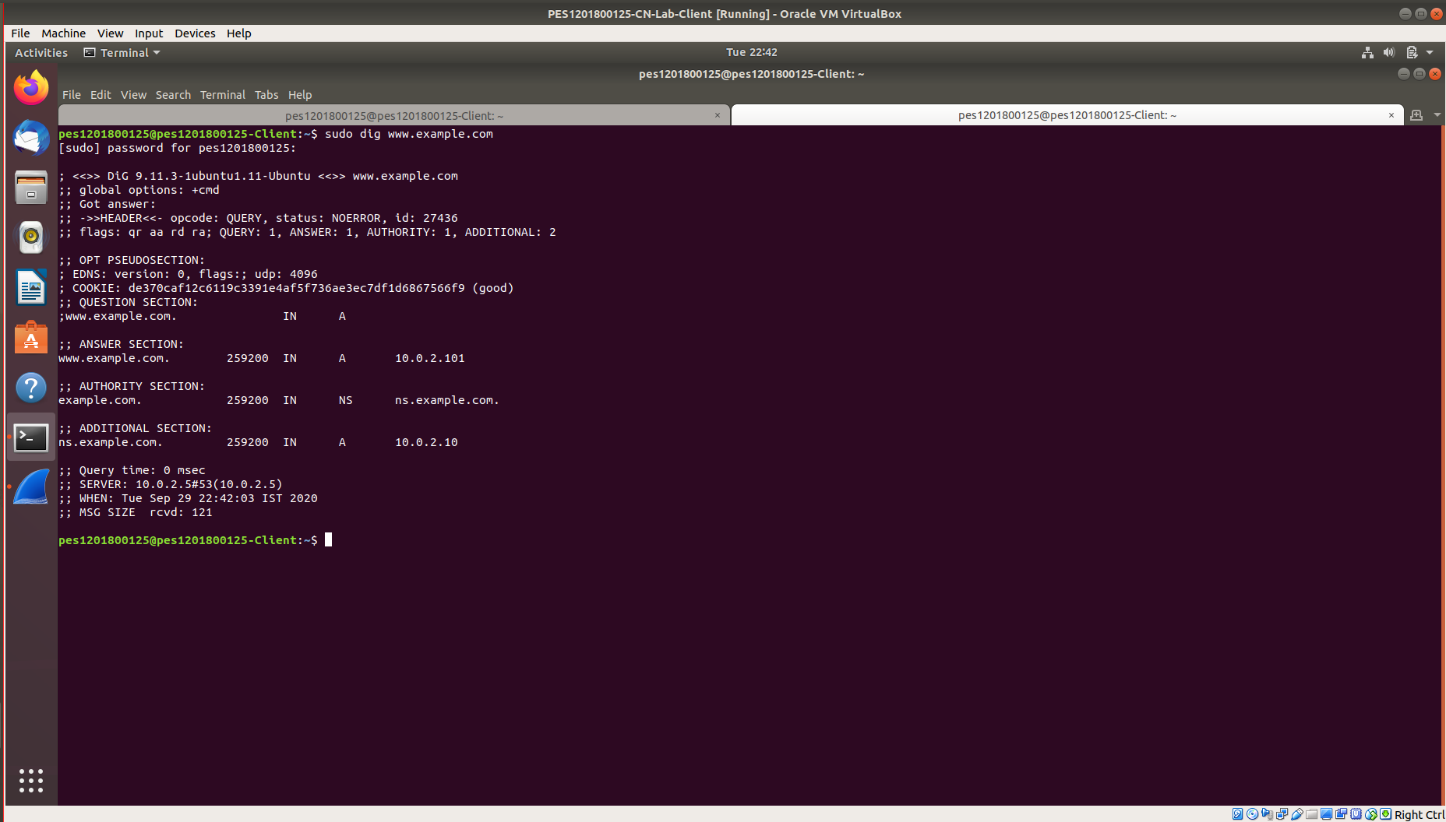

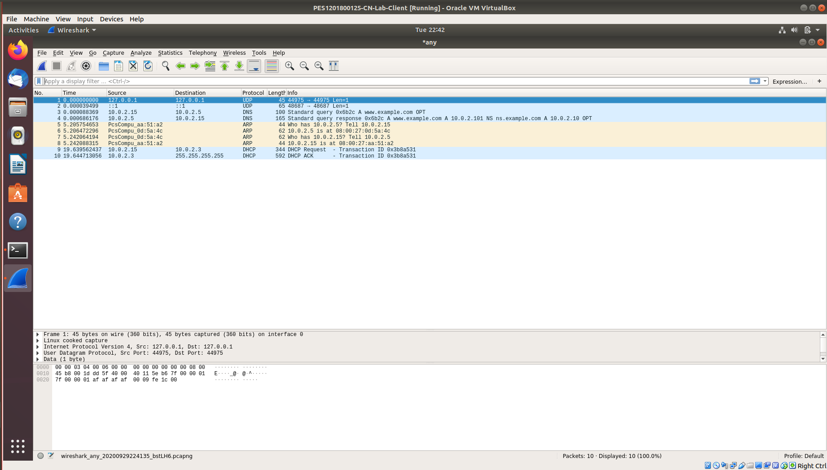

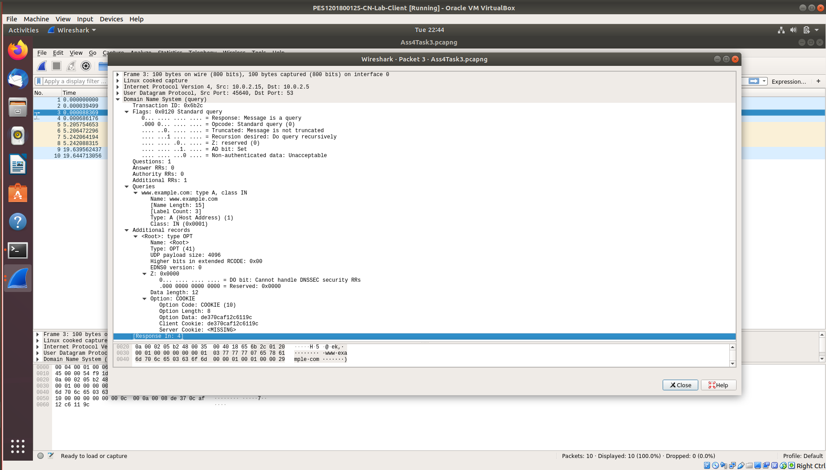

LOCAL DNS Cache

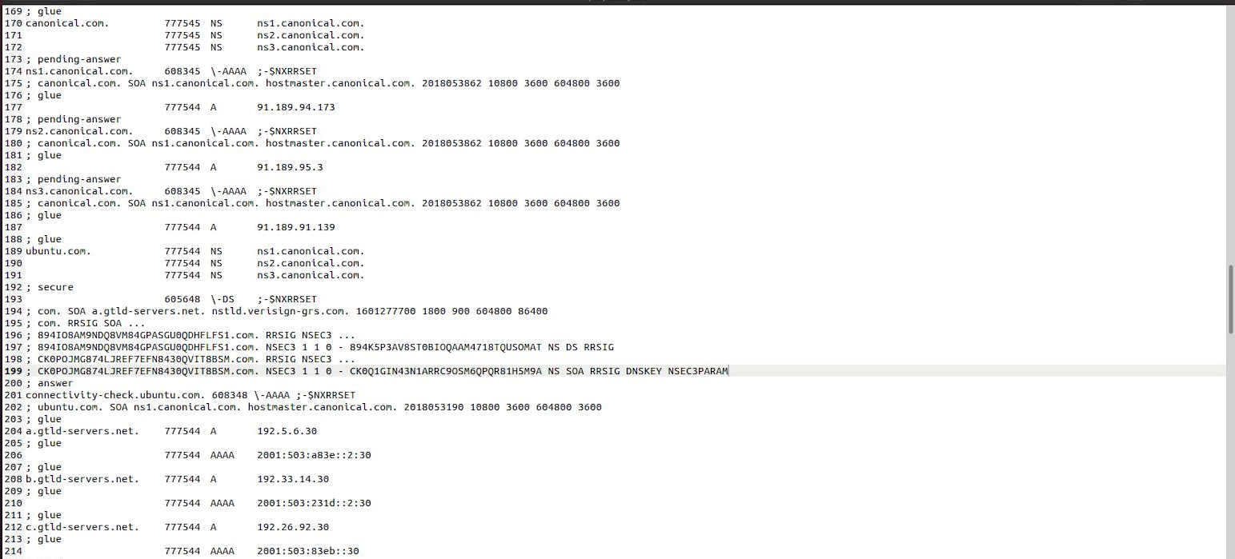

Observations :

1) Locate the DNS query and response messages. Are then sent over UDP or TCP?

A1. They are sent over UDP.

2) What is the destination port for the DNS query message? What is the source port of DNS response message?

A2. The destination port for the DNS query message is 53 and the source port of the DNS response message is 53.

3) To what IP address is the DNS query message sent? Use ipconfig to determine the IP address of your local DNS server. Are these two IP addresses the same?

A3. DNS query message is sent to 127.0.0.53 . The local DNS server has IP : 10.0.2.5 These two IP addresses are not same.

4) Examine the DNS query message. What “Type” of DNS query is it? Does the query message contain any “answers”?

A4. This DNS query is of type A. The query message contains the information about the same under QUERIES header which is :

www.flipkart.com: type A, class IN

No, it does not contain any answers.

5) Examine the DNS response message. How many “answers” are provided? What do each of these answers contain?

A5. There are 2 answers provided. Each of these answers contain the following info.

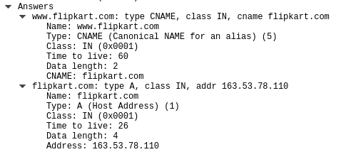

6) Consider the subsequent TCP SYN packet sent by your host. Does the destination IP address of the SYN packet correspond to any of the IP addresses provided in the DNS response message?

A6. The destination IP address of the SYN packet correspond to the IP address 163.53.78.110. This is the same IP address that’s provided to us in the response message as well.

